**The British Association of Prosthetists and Orthotists Member and Non-Member 2021 Survey Report**

Table of Contents

Who has produced this report? 3

1. A brief overview of the report 4

2. Method 4

2.1. Survey 4

2.2. Analysis 4

2.2.1. Quantitative approach 4

2.2.2. Qualitative approach 4

3. Results 5

3.1. Respondents 5

3.2. Quantitative analysis 5

3.2.1. Current employment 5

3.2.2. Membership 6

3.2.3. Education and Training 10

3.2.4. BAPO’s role 13

3.2.5. BAPO’s performance 14

3.3. Qualitative analysis 16

3.3.1. Summary of Thematic Analysis findings 16

3.3.2. Thematic analysis 16

4. Reflecting on the findings to inform future direction 20

5. BAPO’s response 21

6. References 22

Appendix 1 23

**Table of Figures**

Figure 1 Current professional roles of respondents. 5

Figure 2 Mode of employment of respondents. 6

Figure 3 Professional insurance cover of respondents. 6

Figure 4: Respondents’ belief that BAPO membership is value for money. 7

Figure 5 Current membership status of respondents. 7

Figure 6 Consideration of respondents who have never been a member to joining BAPO. 8

Figure 7 Respondents’ interest in joining BAPO committees. 8

Figure 8 Respondents’ barriers to joining a BAPO committee. 8

Figure 9 Respondents’ opinions on the most valuable aspects of professional membership. 9

Figure 10 Respondents’ opinions regarding if BAPO meets their expectations of what a professional body should offer its members. 9

Figure 11 Respondents’ responses to courses BAPO should focus on. 11

Figure 12 Respondents’ responses to interest in online training courses. 11

Figure 13 Respondents’ responses to barriers in accessing BAPO’s training and education. 12

Figure 14 Respondents’ ratings of BAPO’s education offering. 12

Figure 15 Respondents’ opinions on the value of workshops to help people prepare for their first job. 12

Figure 16 Respondents’ opinions on what BAPO should focus on influencing. 13

Figure 17 Respondents’ opinions regarding if BAPO are an ambassador for the UK P&O profession. 13

Figure 18 Respondents’ opinions on support received from BAPO. 14

Figure 19 Respondents’ ratings of BAPOConnect magazine content. 14

Figure 20 Respondents’ opinions on how well BAPO advertises job vacancies. 15

Figure 21 Respondents’ ratings on the BAPO website. 15

Figure 22 Respondents’ opinions on the most valuable parts of the BAPO website. 16

Figure 23 Respondents’ opinions on the usefulness of BAPO’s communications. 16

Figure 24.A word cloud presenting a visual representation of respondents’ feedback. 20

# 

# Who has produced this report?

The British Association of Prosthetists and Orthotists (BAPO) commissioned Staffordshire University to analyse the data from the 2021 BAPO member and non-member survey. The survey was originally designed by CreateFuture consultancy in collaboration with BAPO’s Executive Committee. BAPO distributed the survey.

**The research team who analysed the survey data and produced this report:**

Dr Nicky Eddison1,2 (Consultant Orthotist/Associate Professor)

Sian Calvert1 (Research associate)

Dr Aoife Healy1 (Associate Professor)

Professor Nachiappan Chockalingam1

1Staffordshire University

2The Royal Wolverhampton NHS Trust

**What was the purpose of the survey?**

The purpose of the survey was to inform a strategic roadmap that will contribute towards improved engagement between BAPO, its members and potential future members.

# A brief overview of the report

This report provides a summary of the findings from the British Association of Prosthetists and Orthotists (BAPO) 2021 survey. The survey was completed by 231 individuals, inclusive of BAPO members and non-members, Prosthetists, Orthotists, students, technicians, practising and non-practising. The current report focuses on presenting the analysis of the survey data, to offer feedback to BAPO members and non-members and help identify priorities that could be targeted in future strategies.

# Method

## Survey

The BAPO survey included a mixture of both closed- and open-ended questions. The first part of the survey asked respondents for demographic information about their current BAPO membership status, their job role and employment arrangements, the analysis of this data will be explored in the second part of this document. The second part of the survey focused on gathering feedback about BAPO from respondents, for example, about their thoughts regarding membership, what should be included as part of being a member, and what the focus of BAPO should be.

## Analysis

### Quantitative approach

The survey asked respondents 17 closed-ended questions which focused on five main themes 1) Current employment 2) Membership 3) Education 4) BAPO’s role 5) Opinions on BAPO’s performance. Descriptive statistics of the closed-ended questions were completed.

### Qualitative approach

A qualitative approach was employed to help provide insight into respondents’ perceptions about BAPO, to help identify priorities that could be targeted in future strategies. Qualitative data (responses from 20 open-ended questions from the BAPO survey, see Appendix for questions) was exported into NVivo Pro 12 software 1 to conduct thematic analysis. The qualitative analysis was guided by the 6 stages of thematic analysis 2,3 which were: *familiarisation*, which required immersion in the data*; coding*, which involved identifying important features of the data to create the initial codes*; generating initial themes,* which involved sorting and grouping the initial codesto identify broader patterns of meaning to develop initial themes, at this stage themes were reviewed and discussed by all four authors for meaning and consistency*; reviewing and developing themes,* which is where the themes are then checked against the data to make sure they tell a compelling story of the data; *refining, defining and naming themes,* which is where a detailed analysis of each theme was conducted to check the focus and scope of the themes*;* and *writing up*, which is where the data is presented to present a story of the data.

# Results

## Respondents

57% of respondents were BAPO members, 32% of respondents had been a BAPO member previously, and 11% of respondents had never been a BAPO member and of these 11% all but one had heard of BAPO before this survey. 52% of respondents were Orthotists, 18% were Prosthetists, 17% were managers, 8% were educators or researchers, 7% were students, 4% were technicians, 3% were product specialists, 0.9% were retired, 0.4% were admin, and 0.4% had left the profession (respondents could select more than one response option). 42% of respondents were employed by the NHS, 40% were employed by contractors, 16% worked in private practice, 8% were not practising or were a student or were retired, 5% worked as locums, 2% worked in higher education, and 1% specified other e.g., business owner (respondents could select more than one response option).

## Quantitative analysis

### Current employment

Respondents were asked to describe their current role, the most prevalent roles were Orthotists (52.2%), Prosthetists (17.8%) and managers (16.5%), see figure 1.

Figure 1 Current professional roles of respondents.

In terms of employment, the majority of respondents reported they were employed directly by the NHS (41.6%) or a contractor (40.3%), the next most prevalent employment was private practice (15.5%), see figure 2.

Figure 2 Mode of employment of respondents.

44% of respondents reported that they do not currently have professional insurance in place. See figure 3.

Figure 3 Professional insurance cover of respondents

### Membership

The survey explored questions around membership status, although the majority of respondents reported being BAPO members (57%), a further 33% reported previously being a member and 11% reported that they had never been a member. The respondents were asked to rate whether they believed BAPO membership is good value for money (0 = Strongly disagree to 5= Strongly agree), with the majority of respondents selecting 3, see figure 4. The majority of respondents who were BAPO members paid for their own membership (92%) with a small number of respondents stating their membership was paid for by their employer (8%). Of those respondents who have never been BAPO members (25 responses), 58% reported that have never considered joining the association, see figures 5 and 6. When asked if the respondent had ever served on a BAPO committee 53% (71/133 responses) reported that had not, with 76% (175/230) of respondents reporting they are not interested in finding out how they can support BAPO as a committee member or volunteer. See figure 7. The biggest barrier to serving on a BAPO committee was not having enough time, see figure 8.

Figure 4: Respondents’ belief that BAPO membership is value for money.

Figure 5 Current membership status of respondents.

Figure 6 Consideration of respondents who have never been a member to joining BAPO.

Figure 7 Respondents’ interest in joining BAPO committees.

Figure 8 Respondents’ barriers to joining a BAPO committee.

Respondents reported the top three most valuable aspects of professional membership as 1) Education and training 2) CPD and 3) National representation, see figure 9.

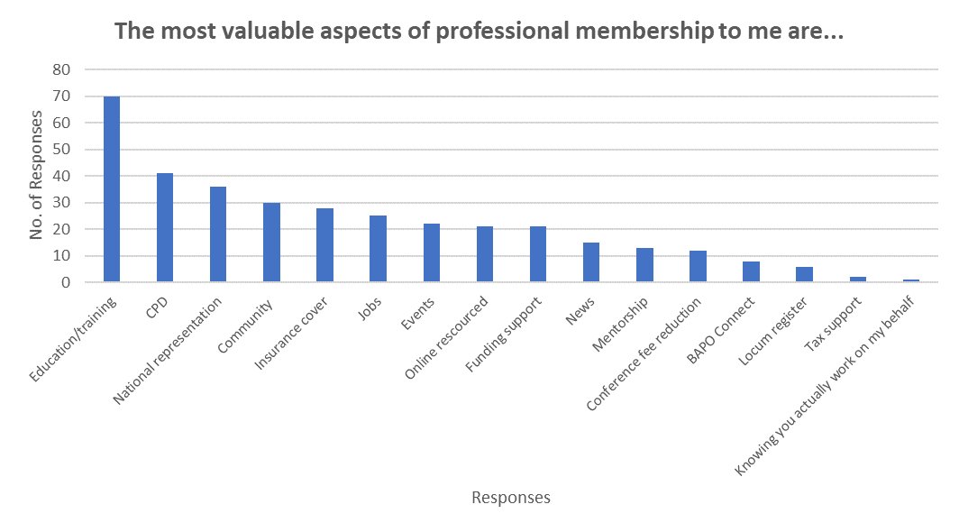

Figure 9 Respondents’ opinions on the most valuable aspects of professional membership.

Respondents were asked how much they agree or disagree with the statement, ‘*BAPO meets my expectations of what a professional body should offer its members*’ (0 = strongly disagree and 5 = strongly agree), the majority rated it a 3, see figure 10. 51% of members also stated that they knew how to raise an issue with BAPO, or how to propose a change or a project for BAPO to work on.

Figure 10 Respondents’ opinions regarding if BAPO meets their expectations of what a professional body should offer its members.

### Education and Training

Respondents were asked what kind of courses they would like BAPO to focus on, 225 of 231 respondents answered this question. The top three responses were 1) Advanced practice 2) Virtual training courses and 3) Leadership courses/mentoring/network, see figure 11. A huge majority of respondents reported that they would be interested in online training courses (150/157 responses), see figure 12, which supports the request in the previous question for BAPO to focus on virtual training courses. However, when asked if there are any barriers to accessing training and education via BAPO, the majority of respondents reported that cost was a barrier (100/196 responses), see figure 13.

The respondents were asked to rate BAPO’s education offering on a scale of 0 (very poor) to 5 (very good), the majority chose a rating of 3 (45/127), see figure 14. The survey also indicated that respondents felt that a workshop to help people prepare for their first job would be “very valuable” (44/128 responses), see figure 15.

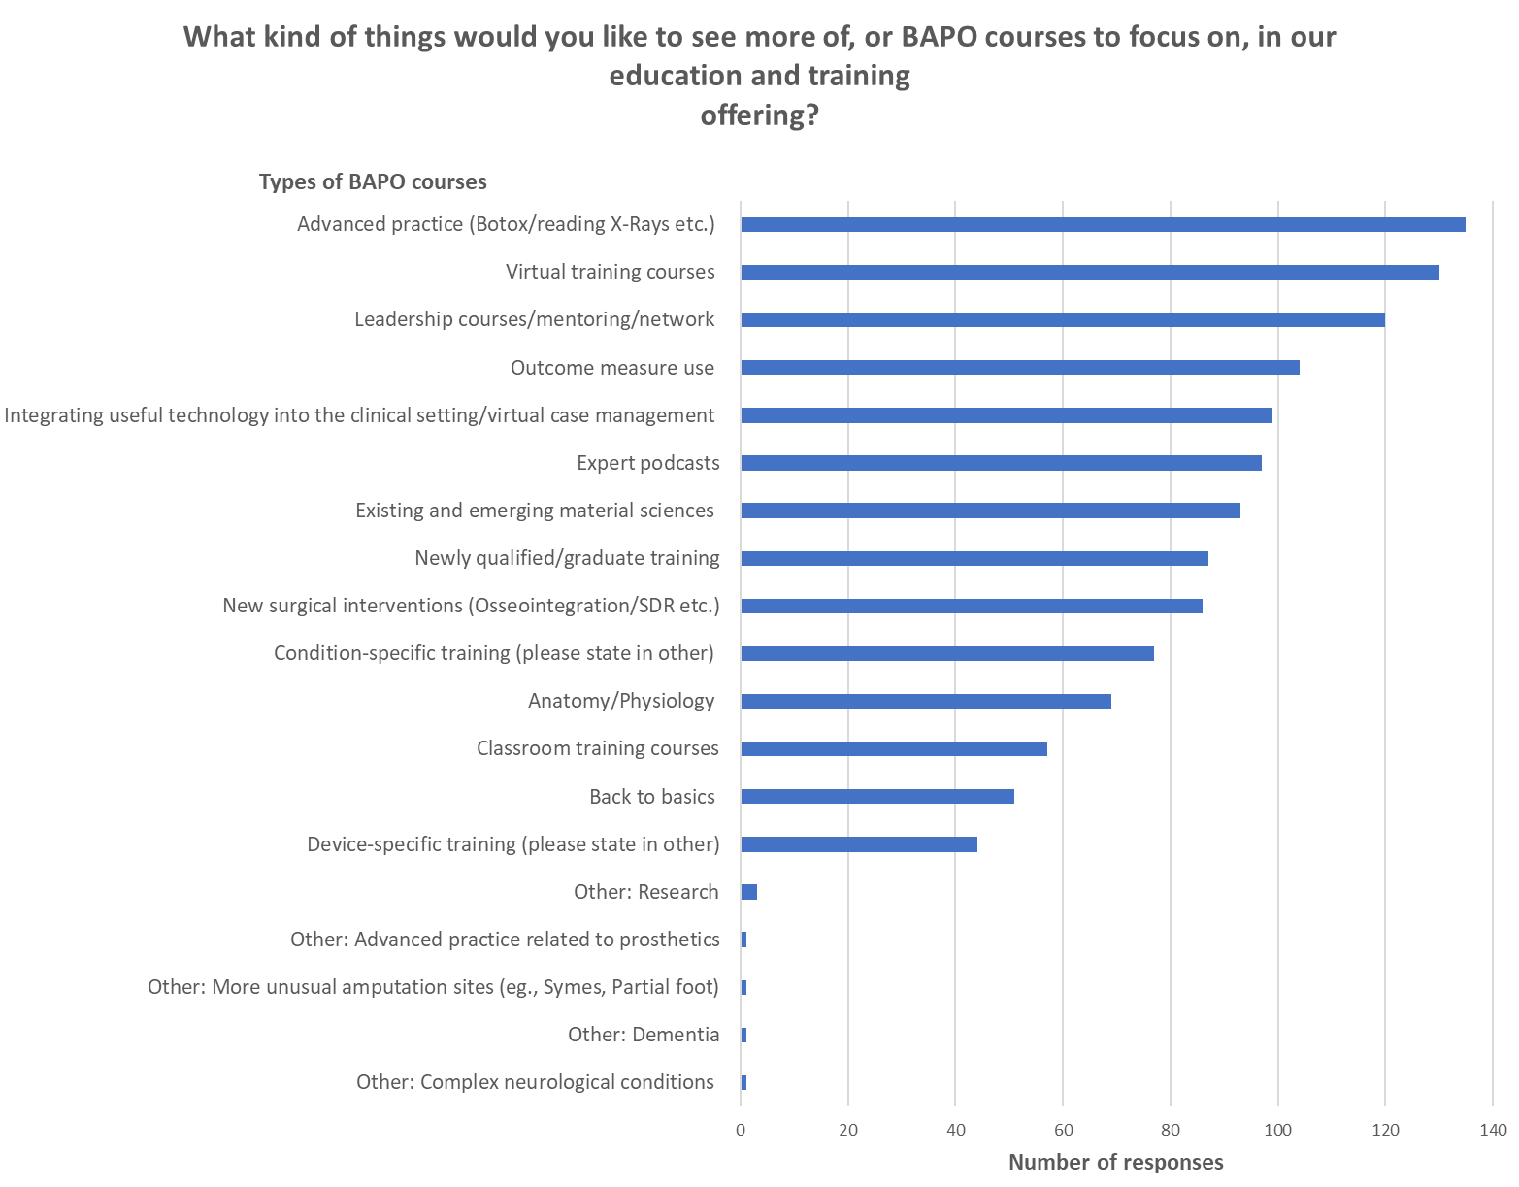

Figure 11 Respondents’ responses to courses BAPO should focus on.

Figure 12 Respondents’ responses to interest in online training courses.

Figure 13 Respondents’ responses to barriers in accessing BAPO’s training and education.

Figure 14 Respondents’ ratings of BAPO’s education offering.

Figure 15 Respondents’ opinions on the value of workshops to help people prepare for their first job.

### BAPO’s role

The survey explored the respondents’ opinions on BAPO’s role, asking what they thought BAPO “should focus on influencing”. The most prevalent response suggested BAPO should focus on influencing NHS Trusts/Health boards (74%), followed by Commissioners of P&O services (62.5%) and Government policymakers (62.5%). Note, respondents could choose more than one answer, see figure 16.

When asked whether they thought BAPO are the “ambassadors of the UK P&O profession” via a scale of 0-5 (0 = Strongly disagree and 5= Strongly agree), the majority of respondents chose 3, however, this question was only answered by 24 of the 231 respondents, see figure 17.

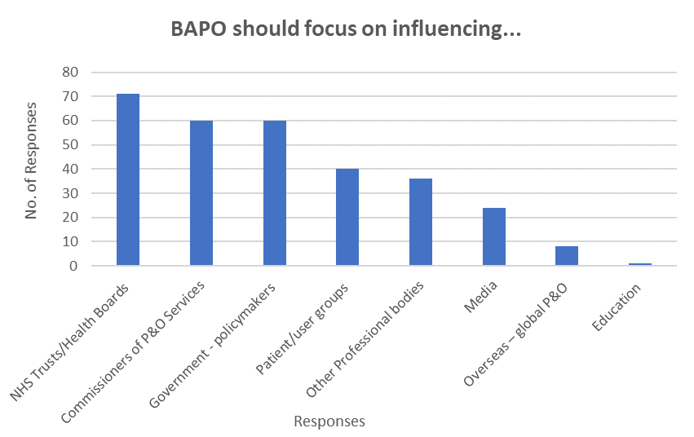

Figure 16 Respondents’ opinions on what BAPO should focus on influencing.

Figure 17 Respondents’ opinions regarding if BAPO is an ambassador for the UK P&O profession.

42 out of 133 respondents stated they had reached out to BAPO for support and most of those respondents rated (on a scale of 0 - Very poor to 5 – Very good) their experience as 3 or above, see figure 18.

Figure 18 Respondents’ opinions on support received from BAPO.

### BAPO’s performance

The survey provided respondents with two Likert scale questions to explore their opinions on BAPO’s performance, the questions focused on the quarterly magazine BAPOConnect and advertising job vacancies. The majority of respondents stated that they read BAPOConnect (120/131 responses) and on a star rating from 1-5, the majority of respondents rated BAPOConnect as 4 (72/120 responses), see figure 19. When asked to rate how well BAPO advertises job vacancies, on a scale of 0-5 (0= very poor and 5= very good), the majority of respondents gave a rating of 3 (52/129 responses), see figure 20.

Figure 19 Respondents’ ratings of BAPOConnect magazine content.

Figure 20 Respondents’ opinions on how well BAPO advertises job vacancies.

Respondents were also asked to rate BAPO’s website on a scale of 0-5 (0= Very poor and 5= Very good) with the majority of respondents giving a rating of 3, see figure 21. Respondents mostly valued the education resources on the website, see figure 22. Respondents were asked to rate the usefulness of BAPO communications on a scale of 0-5 (0 = not useful at all and 5 =very useful), with the majority rating it as 3 or above, see figure 23. 45% of respondents would be happy to be contacted again to discuss their responses to the survey.

Figure 21 Respondents’ ratings on the BAPO website.

Figure 22 Respondents’ opinions on the most valuable parts of the BAPO website.

Figure 23 Respondents’ opinions on the usefulness of BAPO’s communications.

## Qualitative analysis

### Summary of Thematic Analysis findings

The thematic analysis produced two main themes, which were *Focus of dissatisfaction* and *Future direction.* The findings from the thematic analysis suggest that respondents felt that BAPO membership was expensive, which may be related to the idea that respondents are unclear about what the individual benefits of membership are. Respondents believed that BAPO should be helping to increase the professional profile of Prosthetists and Orthotists, offering more training opportunities, setting out best practices, providing professional support, and assisting with networking.

### Thematic analysis

#### Focus of dissatisfaction

The first theme discusses the focus of respondents’ dissatisfaction. This theme has two sub-themes: *expensive* and *uncertain about the benefits.*

*Expensive*

Echoed by many respondents was the perception that BAPO membership was “*Too expensive”* (Respondent, 5) and *“It seems like a lot of money for insurance”* (Respondent, 11). If the membership fee was *“More affordable”* (Respondent, 54) or “*if the cost was reduced to join, I really would join again”* (Respondent, 19). Even though respondents felt as though membership was expensive, they felt that BAPO was important for the profession, and they would continue to pay for membership regardless.

*“I do believe BAPO is important for the profession and does good work representing us so will continue to support it as long as I am able to afford to”* (Respondent, 11).

Whilst the majority of respondents felt that the cost of membership was expensive, this was not echoed by students: *“Good to be involved in the association for a cheap price as a student”*

(Respondent, 70). Respondents also suggested that BAPO could offer different types of membership to make it appealing and affordable to a range of professionals, for example, *“That they would have a non-practising membership level”* (Respondent, 224).

*Uncertain about the benefits*

There is some suggestion that respondents are not sure what the individual benefits of being a BAPO member are:

*“I think BAPO is essential for the wider profession, but it is not always easy to see how it benefits me as an individual. I see it in the same way as contributing to charity, I do it because it’s the right thing to do”* (Respondent, 205)

This might go to further explain why they felt that membership was expensive: *“It is a large amount of money, and unsure why such a large cost, what does it provide me”* (Respondent, 59). Respondents seem to perceive they are paying a “*Monthly payment without monthly benefits”* (Respondent, 221). This also could be related to the feeling that *“I do not know much about BAPO”* (Respondent, 8)and members may recognize the benefits of being a member if they had a:

*“Better understanding of what BAPO does for me, and how you* [BAPO] *are working to improve the profession”* (Respondent, 7)

#### Future direction

The second theme discusses potential areas of improvement that could be targeted in future priorities. This theme has five sub-themes: *increasing the professional profile, training opportunities, setting out best practices, professional support* and *supporting networking.*

*Increasing the professional profile*

Respondents believed that BAPO should be working to help increase the professional profile of Prosthetists and Orthotists: *“Create more awareness of the profession”* (Respondent, 86). Respondents suggest that this could be done by, *“Promoting what we do”* (Respondent, 25) using *“marketing campaigns”* (Respondent, 80) through *“Social media”* (Respondent, 22) channels to increase visibility; including using “*younger social media platforms”* (Respondent, 213) to reach a wider audience. This could lead to more people joining BAPO and *“therefore a larger voice”* (Respondent, 44). There was some discussion about there being a *“Shortage of clinicians”* (Respondent, 73) and working to increase the awareness of the profession, this would help support retention and growth of the workforce. Respondents suggested that BAPO should be developing links with universities to raise awareness of the profession to encourage more individuals to choose prosthetics or orthotics as a career: *“Training more prosthetists/orthotists and making our professions more well-known”* (Respondent, 210). Further, BAPO could *“Show students why it’s important to be a member of BAPO”* (Respondent, 63) since as members they could help *“to influence and support future practitioners”* (Respondent, 71).

*Training opportunities*

A common suggestion was that BAPO should be offering (or signposting to) *“More courses”* (Respondent, 19) and continued professional development opportunities (CPD): *“More linking up with other professional bodies to share relevant CPD opportunities”* (Respondent, 35). Respondents would like more online training opportunities and webinars.

*“Regular small online CPD events - accessible to more, both geographically, in terms of time, and cost*” (Respondent, 55).

Online training could minimize costs: “*Virtual educational content (with or without cost) on the website”* (Respondent, 204), and training sessions could be recorded so to be reviewed at a time convenient to the individual: “*Online training in various subjects recorded to watch at our leisure”* (Respondent, 5) and with a bigger focus on specific training for prosthetics: *“Prosthetic training courses*” (Respondent, 36).

*Setting out best practice*

Respondents discussed that they think BAPO should be guiding and providing a *“collection of best practice guidelines”* (Respondent, 93) and that BAPO as a professional body should be helping to ensure that everyone is working to the same guidance:

*“The governing body of prosthetists and orthotists to ensure everyone is working to the same guidelines and expectations”* (Respondent, 71).

Respondents also discussed that “*guidelines could be reinforced”* (Respondent, 57) to help standardise best practice to ensure “*Consistency across centres”* (Respondent, 69); “*Making things more standardized throughout the profession and between jobs including appointment times and responsibilities”* (Respondent, 56).

*Professional support*

Respondents believed that BAPO should be a place to seek professional support and advice:

*“There needs to be some form of pathway to allow members to discuss concerns they have in terms of their job i.e., bullying (where HR haven't been supportive), job retention concerns especially throughout Covid”* (Respondent, 19).

This could be done via a *“Telephone/email advice service for workplace-related support/advice”* (Respondent, 94). BAPO could communicate and explain to members, *“ways in which you [BAPO] can support professionals in their day-to-day role”* (Respondent, 226). Furthermore, respondents expressed that they would like to see BAPO offer more *“Career progression advice/support”* (Respondent, 36) and up to date, *“job opportunities”* (Respondent, 220), “*within the UK”* and “*More from global P&O* [Prosthetists and Orthotists] *e.g., China*” (Respondent, 66).

*To actually see the job adverts. Maybe in biweekly email, not via post and if you do maybe more than one job in an envelope.* (Respondent, 36), or “*Share vacancies on social media”* (Respondent,55).

*Supporting networking*

Helping members make connections and share knowledge by supporting the set-up and coordination of regional and national meetings, is something respondents would like to see BAPO doing. “*Monthly /quarterly community meetings*” (Respondent, 51) as *“There used to be regional BAPO meetings which I thought worked well”* (Respondent, 76). Respondents also suggested that a *“Free forum”* (Respondent, 45) could be another way of sharing knowledge and communicating with other professionals, so there is *“a kind of platform where Orthotist* Text
*and prosthetists can talk or exchange their opinion”* (Respondent, 40).

Figure 24.A word cloud presenting a visual representation of respondents’ feedback.

Respondents indicated amongst other things that they would like more online courses with a specific focus on advanced practice, more information about membership benefits, and thought given to the cost of membership (Figure 24).

# Reflecting on the findings to inform future direction

The findings from the qualitative and quantitative analysis provide the following insight for future consideration by BAPO:

* Increasing communication and engagement with members about what the benefits are for the individuals when paying for membership.
* Increasing visibility on social media, including different platforms, and developing links with universities to help with raising the profile of the profession and increasing the workforce.
* Providing more training opportunities, preferably delivered online to reduce cost and recording training sessions so they can be viewed at a convenient time. With a particular focus on advanced practice and leadership.
* Communicating best practices
* Providing information to members about what professional support and advice are available and how to join BAPO Committees.
* Supporting the set-up and coordination of regional and national meetings, to support networking and sharing of knowledge.
* Communicating the requirement of HCPC for registered members to have indemnity insurance.

# BAPO’s response

BAPO is grateful to all who responded to the 2021 member and non-member survey. The data and analysis presented by Staffordshire University highlights what is important to members and will guide the actions of the executive.

The results and analysis of the survey have informed a new BAPO strategic plan 2022 – 2024. This plan, which will be presented to the membership during the first half of 2022, provides a pathway for development of the association aligned to what the respondents have asked us to focus on, and one which we hope will see the association thrive, by both attracting new members and retaining current members.

BAPO recognises the need to:

* Be more relevant and visible to all members, regardless of location, discipline, or employment.
* Provide increased resources, particularly for continuing professional development (CPD).
* Provide the profession with a voice that is both louder and clearer, to exert greater influence, whilst enhancing our public presence.

As part of a post COVID-19 recovery effort, BAPO will pursue a vision for 2022-24 informed by this study and that vision is:

*BAPO will enable our members to transform lives and improve the health of the UK population, through health outcomes which significantly benefit those who receive prosthetic and orthotic care.*

# References

1. QSR International Pty Ltd. Published online 2016.

2. Braun V, Clarke V. Using thematic analysis in psychology. *Qual Res Psychol*. 2006;3(2):77-101.

3. Braun V, Clarke V. Reflecting on reflexive thematic analysis. *Qual Res Sport Exerc Heal*. 2019;11(4):589-597.

4. *Health and Care Professions Council. Information for Registrants Professional Indemnity and Your Registration*.; 2014. Accessed March 5, 2022. https://www.hcpc-uk.org/resources/guidance/professional-indemnity-and-your-registration/

# Appendix 1

Questions included in the Thematic Analysis

1d. What kinds of additional support from BAPO would make your professional life better?

2c. If you have stepped down from a BAPO committee after sitting on one in the past, what were your reasons for stepping down?

2f. Can you tell us a little about why you gave your previous answer?

2i. What would you like to see BAPO offering its members / doing differently to meet your expectations of a professional body?

3b. Of the main issues that will affect the profession over the next 5 years - which ones should BAPO focus on?

3c. How do you think a membership organisation like BAPO should be representing you?

3g. Was there anything we could have done better?

3k. Is there anything you'd like to see us do more of on social media?

3l. How do you think we can connect better with the Prosthetic and Orthotic community?

5b. What would you like to see more of with our Jobs offerings/advertisements?

7a. What were your first impressions of BAPO, and do you think - as an organisation - it lives up to expectations?

7b. How would you describe your understanding of what BAPO does?

7d/8b/9e. Where do you think BAPO should be seen and heard to influence the P&O world?

7f/8a/9d. How do you think we can connect better with the Prosthetic and Orthotic communities?

7h. What has stopped you from joining BAPO so far?

7i/8d. Where do you go for professional support?

7k. Are there any other benefits that you'd like to see BAPO offer?

9a. Why did you choose not to renew your membership?

9b. What would inspire you to join again?

10a. Do you have any additional comments you'd like to give us?